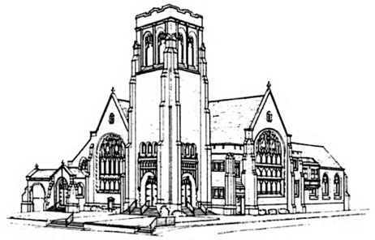
First Presbyterian Church

July 23, 2023
Eighth Sunday After Pentecost

Handbell Chimes—The ringing of the chimes invites you to a time of Rest…Renewal…Hope

Prelude Lucas Brown, piano

Opening Sentences
One: Cry out with joy to the Lord, all the earth! Worship the Lord with gladness. Come into God’s presence with singing!
All: For the Lord is a gracious God, whose mercy is everlasting; and whose faithfulness endures to all generations.

* Hymn #645 (insert) “Sing Praise to God Who Reigns Above”

* Invitation to Experience God’s Grace (1 John 1:8-9)
One: If we say we have no sin, we deceive ourselves, and the truth is not in us. But if we confess our sins, God who is faithful and just will forgive us our sins and cleanse us from all unrighteousness.
All: In humility and faith we will confess our sin to God.

* Laying Down Our Burdens
All: Merciful God, we confess that we have sinned against you in thought, word, and deed, by what we have done, and by what we have left undone. We have not loved you with our whole heart and mind and strength. We have not loved our neighbors as ourselves.
In your mercy forgive what we have been, help us amend what we are, and direct what we shall be, so that we may delight in your will and walk in your ways, to the glory of your holy name.

* Silent Prayer

* Declaration of Forgiveness
One: Hear the good news! Who is in a position to condemn? Only Christ, and Christ died for us, Christ rose for us, Christ reigns in power for us, Christ prays for us. Anyone who is in Christ is a new creation. The old life has gone; a new life has begun. Know that you are forgiven and be at peace.
All: Thanks be to God! Amen.

*We Celebrate God’s Forgiveness Glory Be to the Father (Gloria Patri) #579

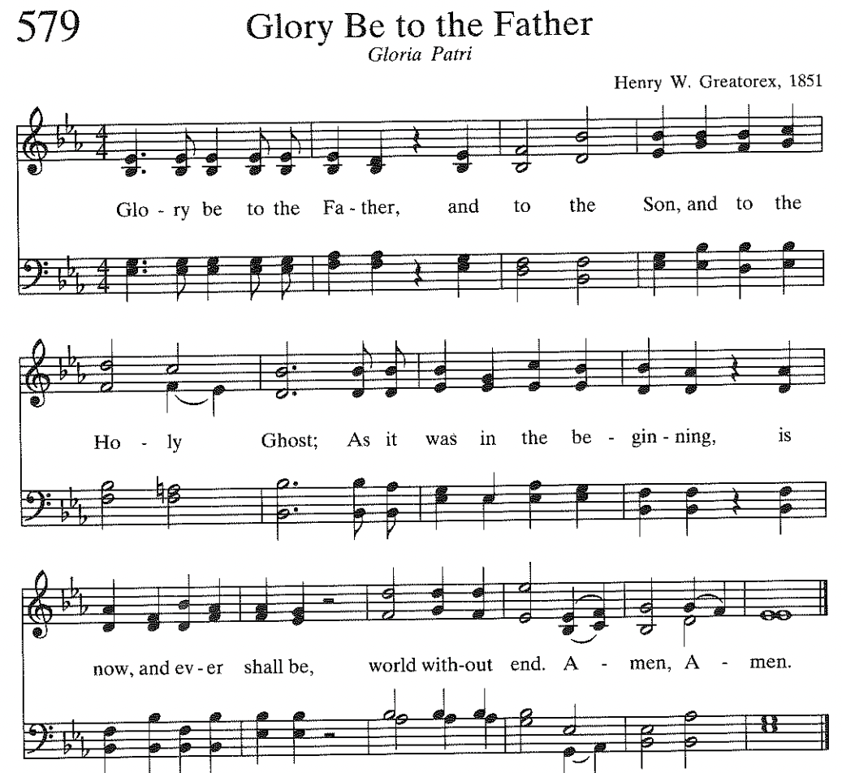

* Sharing the Peace of Christ
One: As God has forgiven us, let us forgive one another. The peace of the Lord Jesus Christ be with you.
All: And also with you.

* Children’s Message

* Celebrating the Life of the Congregation

* Prayer for Illumination
All: O Lord our God, your Word is a lamp to our feet and a light to our path. Give us grace to receive your truth in faith and love, that we may be obedient to your will and live always for your glory; through Jesus Christ our Savior. Amen.
Scripture Reading: Genesis 28:10-19
10 Jacob left the town of Beersheba and started out for Haran. 11 At sunset he stopped for the night and went to sleep, resting his head on a large rock. 12 In a dream he saw a ladder that reached from earth to heaven, and God's angels were going up and down on it.

13 The Lord was standing beside the ladder and said:
I am the Lord God who was worshiped by Abraham and Isaac. I will give to you and your family the land on which you are now sleeping. 14 Your descendants will spread over the earth in all directions and will become as numerous as the specks of dust. Your family will be a blessing to all people.] 15 Wherever you go, I will watch over you, then later I will bring you back to this land. I won't leave you—I will do all I have promised.
16 Jacob woke up suddenly and thought, “The Lord is in this place, and I didn't even know it.” 17Then Jacob became frightened and said, “What a frightening place! It must be the house of God and the gateway to heaven.”

18 When Jacob got up early the next morning, he took the rock that he had used for a pillow and stood it up as a place of worship. Then he poured olive oil on the rock to dedicate it to God, 19 and he named the place Bethel. Before that it had been named Luz.

20 Jacob solemnly promised God, “If you go with me and watch over me as I travel, and if you give me food and clothes 21 and bring me safely home again, you will be my God. 22 This rock will be your house, and I will give back to you a tenth of everything you give me.”

One: Holy wisdom, holy Word.
All: Thanks be to God.

Sermon “A World of Trouble on My Mind”

We Affirm our Faith The Apostles’ Creed
I believe in God the Father Almighty, Maker of heaven and earth,
And in Jesus Christ his only Son our Lord; who was conceived by the Holy Ghost, born of the Virgin Mary, suffered under Pontius Pilate, was crucified, dead, and buried; he descended into hell; the third day he rose again from the dead; he ascended into heaven, and sitteth on the right hand of God the Father Almighty; from thence he shall come to judge the quick and the dead. I believe in the Holy Ghost; the holy catholic Church; the communion of saints; the forgiveness of sins; the resurrection of the body; and the life everlasting. Amen.

GIVE THANKS TO GOD
Prayers of the People

The Lord’s Prayer
Our Father who art in heaven, hallowed be thy name. Thy kingdom come, thy will be done, on earth as it is in heaven. Give us this day our daily bread; and forgive us our debts, as we forgive our debtors; and lead us not into temptation, but deliver us from evil. For thine is the kingdom and the power and the glory, forever. Amen.

Practicing Abundant Generosity https://onrealm.org/FirstPresbyteri11244/give/now

Offertory: "My Lord, What a Morning" arr. Sue Ellen Page
Women’s Choir Nancy Ruth Wainwright, Director
* Doxology #592 (below) “Praise God from Whom All Blessings Flow”
* Recommitting Our Lives to Service

My Lord, What a Morning” is an African American spiritual and was written and composed by free African Americans in the early nineteenth century and most definitely underwent various changes over the years (author unknown). The text is full of biblical imagery of the second coming of Jesus. While it expresses awe and dread of the trumpet and the falling stars, it is also hopeful that God’s promised justice has finally arrived, and even “the nations underground” are included in the promise. -Bud Miller

* Prayer of Dedication

* Hymn #269 (insert) “O God of Bethel, By Whose Hand ”

LEAVE TO SERVE
* Charge and Benediction

Sending Music Lucas Brown, piano

Please use the Postlude time and music to reflect on today’s worship experience and how it will support you in the week to come.
† First Presbyterian’s Session recognizes that throughout U.S. history African American composers have not been compensated equitably for the music they have created. To remedy this in “our little way,” the congregation is invited to make a donation, using this QR code, whenever we sing an African American Spiritual, whether it’s the choir anthem or a hymn. This donation goes directly to The Essence of Harmony Choral Society to assist them in purchasing music, supporting professional musicians, and paying venue fees. The Essence of Harmony Choral Society was formed in 2018 by Cherisse Bonefont. The Choir was born from a need she saw to create the presence of, space for, and a medium through which singers of all skill levels can share their musical gifts with the Burlington County community at large. This diverse group of singers has a cohesive and creative performance style. EHCS focuses explicitly on celebrating the works of both classical and under-recognized African American composers. In addition, the group presents classics and anthems, spirituals, and contemporary gospel music.

Reprinted / Podcast / Streamed with Permission Under
OneLicence #740987-A.
All Rights Reserved.

WELCOME TO FIRST PRESBYTERIAN CHURCH! It is good to have you here in person or online. Please be in touch if you have news to share or would like more information or to talk to a pastor. Staff contact information is below. Read full announcements in our weekly email newsletter, available on the church website. Subscribe on the Contact Us tab.

THE NURSERY care is available in the Hospitality Center – across from Fellowship Hall.

AFTER-WORSHIP HOSPITALITY IS BACK! Linger a moment or two after the service to greet fellow worshippers. And please sign up with a friend or a group to host one Sunday by providing simple refreshments. There is a sign-up on the snack table or contact someone on the Hospitality Committee: jmfiorella@gmail.com, shoemakerjanet68@gmail.com, qlerch2@comcast.net, or phurd75@gmail.com,

PASTOR NIKKI LEADS SUMMER WORKSHOP SERIES– This summer Pastor Nikki is offering three, one-hour workshops after Sunday worship in the Hospitality Center. Light snacks will be provided as well as ample time for questions and discussion!
Sunday August 13: Gun Violence
The Presbyterian Outlook is dedicating its June issue to the topic of gun violence. The Christian Education and Justice and Advocacy committees invite you to join a discussion on August 13. Copies of the issue will be available.

PASTOR NIKKI’S BIBLE STUDY THURSDAYS @ 7 – Pastor Nikki is hosting a Bible Study via Zoom on the book of Genesis entitled “Genesis: Relational and Family Dynamics.” The reading schedule is linked on the Adult Ed page of the website. The Zoom link is https://us06web.zoom.us/j/81798184993, and we will also meet in person at pre-determined times. Please contact Pastor Nikki if you have questions and are interested or join us on Zoom!

The August Porch Bible Study will meet in the Bean Parlor at 4 p.m., on Tuesday, August 15. Our August Porch Lunch will be Tuesday, August 8, at noon at Mulligan's Bar and Grill in Oaklyn. For more information, contact Deb Nussbaum at debranussbaum1987@gmail.com.

WORSHIP ATTENDANCE 7/16/23: 96 in person and 14 online.

2023 CHURCH OFFERING UPDATE – Please note that target numbers on the right now represent a 12 month budget.
Received to date Twelve-month budget goal
Envelope Giving: $ 342,878.00 $ 570,270.00
Loose Offering: $ 6,636.00 $ 12,000.00
Per Capita: $ 8,777.00 $ 16,000.00

PLASTICS FREE CHALLENGE in JULY! CAN YOU DO IT? The Earth is counting on you. How much plastic can you eliminate from your life during the first week of July?
(Not so) Fun Fact: Over nine million metric tons of plastic, including three million metric tons of microplastics, enter the environment globally every year! Plastic lasts hundreds to thousands of years and its toxic remains pose serious challenges.

Worship Activity Bags are now available for children attending worship in
Fellowship Hall this summer. The bags contain coloring sheets and crayons and may be taken home. Children are encouraged to draw on the bags themselves as well as the enclosed activity sheets.

Backpack fillers needed for St Wilfrid’s! Each year FPC and Grace Episcopal Church provide supplies for backpacks for the children of families who receive food bags at St Wilfrid’s. If you would like to help, supplies needed are below:

Pencil cases
Pencils
Pencil sharpeners
Glue sticks
Kid’s scissors
Rulers
Boxes of 24 crayons
Markers
2 pocket folders

Items may be dropped off on Corey Crumley’s porch at 40 Warwick Rd. Haddonfield

CONGREGATIONAL PRAYER LIST

Please pray for the following individuals and situations throughout the week. If you would like to add a personal prayer request, please contact one of the pastors or our new Office Administrator, Olivia Willison. Requests will be revisited every 30 days.
Prayers for the Church
- Pray for the people, government, and country of Ukraine as war continues.
- Please pray for courage and strength to Susan and Nancy as they continue with their cancer treatments (7/20-C. Carty).
- Prayers of comfort for Barbara as she grieves her husband Don (7/19-C. Carty).
- Please pray for the Andreski family as they grieve for Nancy, their beloved wife and mother (7/18- C. Carty)
- Pray for 19-year-old Cole. Cole has battled cancer twice, and was recently diagnosed with a brain tumor and underwent emergency surgery. He is recovering! Pray for continued recovery and full healing! (7/13- T. Adkins)
- Please pray for health and healing for Dottie Peatman (7/12- M. Westermaier)
- Pray for God’s provision and protection over Philip’s upcoming trip home (7/10-P. Chang)
- Please pray for Jason Gilbert who suffered a fall and cut his head. He is being monitored for internal bleeding. Pray for healing! (7/7-M. Dark)
- Please pray for Amy and Brad Strauss, that God would be present in their lives (7/7-pastors).
- Please pray for the ladies incarcerated in Camden County Jail, with specific attention on their living conditions that they would be more rehabilitative, and that they would get to go outside more often (7/6-G. Ladies)
- Please pray for Tiffany, Summer, and Julia; and for their children and grandchildren, and that they will be together soon (7/3-G. Ladies)
- Pray for Carly, her boyfriend John, and her safety (7/2-G. Ladies)
- Please pray for Morgan and Tanisha and their children (7/1-G. Ladies)
- Pray for Jennifer. God knows the needs (6/30-N. Passante)
- Keep Isabel Pross in your prayers as she undergoes cancer treatment (6/27-pastors)
- Pray for Francie’s mom who has gone home to be on hospice (6/26-L. Sommers)
- Continued prayers for Todd (6/25-N. Passante)
- Continued prayers for Susan, who has been diagnosed with brain cancer and a mass in lungs. Help her to feel God’s presence and strength (6/24-C. Carty)
- Please pray for Renee. God knows the needs (6/22-pastors)
- Pray for healing for Antoine of Greenville, SC who is undergoing treatment for colon cancer in the ICU and for Terez and Wizard who are caring for him; may God give them strength and comfort (6/16-J. Wackes)
- Pray for Tony Gramkowski who is recovering from heart surgery and a stroke. He is in an ICU in Boston for his care (6/14 - MB Creamer)

Church Staff
The Rev. Dr. Marvin Lindsay, Senior Pastor and Head of Staff – mlindsay@haddonfieldpres.org
The Rev. Nikki Perrine Passante, Associate Pastor – npassante@haddonfieldpres.org
Peter Leibensperger, Minister of Music – pleibensperger@haddonfieldpres.org
Lucas Brown, Principal Organist – lbrown@haddonfieldpres.org
Katie Beth McBurnie, Director of Children’s Ministry – kmcburnie@haddonfieldpres.org
Nancy Ruth Wainwright, Director of Children’s Choirs – nancyruthw@comcast.net
Marisa McGovern, Preschool Director – preschool@haddonfieldpres.org
Kris Bean, Business Manager – kbean@haddonfieldpres.org
Travis Bogetti, Building Manager – tbogetti@haddonfieldpres.org
Ed Hess, Community Caseworker – edwh517@aol.com
Olivia Willison — officeadmin@haddonfieldpres.org

